

**Team Project - Visual Analytics**

Team Members:

Pranjal Arote

Premlatha Raghunath

Date of Submission: 05/11/2020

Visual Analytics

**Lawrence Technological University**

Table of Contents

Introduction 3

Data Pre-Processing 4

Explore the data 4

List of Charts 5

Patient visits and their risk level 5

Number of doctors in every department 5

Number of patient in each branch 5

Revenue assessment on each doctor 5

Year over year revenue 5

LOD Include 6

Questions 7

Calculations 8

Visualization 9

Patient visits and their risk level 9

Number of doctors in every department 9

Number of patients in each branch 10

Revenue Assessment on each doctor 11

Year over Year revenue 12

LOD Include 13

Dashboard 14

Conclusion 15

References 17

# **Introduction**

Our team has worked on the Hospital dataset to visualize and evaluate the challenges which can further be addressed with the potential solution to enhance the organization workflow more effective and profitable after taking the risk preventive measures. The dataset has the details on patients, doctors, hospital information, departments, profiles, and date, which we used to evaluate the current situation of the hospital that operates in different zones. We explored multiple scenarios like patient risk level, analyzing the revenue, department performance, and doctors' availability for the patient's traffic, which could help with improved management on risk profiles and doctor allotment in each zone.

After our evaluation, we created seven different reports that sustain our analysis to improve hospital performance and to handle patient risk level. The generated seven reports are Patient visits and their risk level, Number of doctors in every department, Number of patients in each branch,Revenue assessment of each doctor, Year over Year revenue, and LOD Include. By administering high-risk profiles and allotting pre-requisite treatment, the patients can have a high possibility of decreasing risk levels that can help department and doctor availability. Revenue assessment to plan possible improvements and oversee the organization's performance.

## Data Pre-Processing

Data pre-processing was not mandatory for the data set we worked on, as we have not witnessed any null values that we can consider into account based on which the integrity of the other values can get impact. We were able to identify specific values to be ‘zero’ at some of the records in the row ‘Date of Discharge,’ which we can consider as the current state of the patient. A current state of a patient describes a situation where the patient is still on diagnosis and does not have a definite ‘Date of Discharge’ value for that particular visit. Considering the data extraction timeline from the database is not live, we have not taken particular patient visits into account that represents the state of the patient to be current or the patients who exemplify value zero.

## Explore the data

We extracted the database records as a file in the '.csv.' format to understand the data and learn the row-level data to analyze further. Once we imported the dataset in Tableau, we were able to identify the rows, type of data, evaluating the scenarios, and a potential solution for the given problems. We used data pane to find the respective fields that can be used to work within the workspace. We used precise calculations as a technique to discover and create necessary measures and dimensions to manipulate the data and get extended values that can enhance the output.

## List of Charts

### Patient visits and their risk level

The extracted data shows four categories General, Speciality, Labs, and Intensive care criteria to which the patients were admitted for diagnosis. The X-axis represent Department Type, and the Y-axis represents the Number of Patient Visits.

### Number of doctors in every department

This chart helps in understanding the number of doctors allocated to each department. The X-axis represent Distinct Count of Doctors, and the Y-axis represents Department type.

### Number of patient in each branch

Consultation towards individual department can be visualized using this chart that summarizes the patient traffic on visitations. The X-axis represent Department details, and the Y-axis represents the Number of Patient Visits towards the relevant department.

### Revenue assessment on each doctor

This chart represents the revenue that is generated by an individual doctor that determines the value of the resource and also can help in determining if the revenue has a chance increase by involving the specialty doctors that show more service time. This chart shows the list of doctors with split rows- Doctors First Name, Doctors Last Name, and Revenue generated by a particular doctor.

### Year over year revenue

This chart helps in analyzing the revenue generated by all departments to administer the development result as increased or decreased with performance yearly. The X-axis represents the Revenue generated by the individual department, and the Y-axis represents Department names.

### LOD Include

This chart Represent the LOD Include expression for Hospital Branch: Central, East, and South for the included departments in each branch along with the. Sum of Include hospital branch(i) broken down by Hospital Branch and Department. Color shows details about Hospital Branch.

# **Questions**

1. Which department type has the highest % of high patient risk profile and which department type has the lowest % of low risk profile.

2. Which department type has less than 10 doctors?

3.Which department has the least number of patients visit?

4. What department type and which doctors have generated revenue assessment <100,000?

5. Which departments have generated higher revenue (2018) than that of previous year (2017)?

6. Which hospital branch has more number of Department?

# **Calculations**

1. 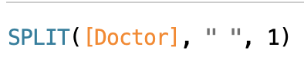

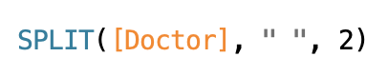

In this above calculation, we have performed the row level aggregation, by using the Transform | Split for the Doctor into Doctors First name and Last name. We have used the above code for splitting the Doctor Dimension. Therefore, we have created these two calculated fields using Split() function.

2. 

For Level of detail (LOD) we have used INCLUDE type of LOD. The basic syntax for LOD is given below, there are three types of LOD, FIXED,INCLUDE and EXCLUDE



Above, INCLUDE LOD expression code is used to compute the values using specified dimension which is Hospital branch along with another dimension which is in the view, which in our case is Department. Here, dimensions we used are Hospital branch, including Department. Measures used is Revenue.

# **Visualization**

### Patient visits and their risk level

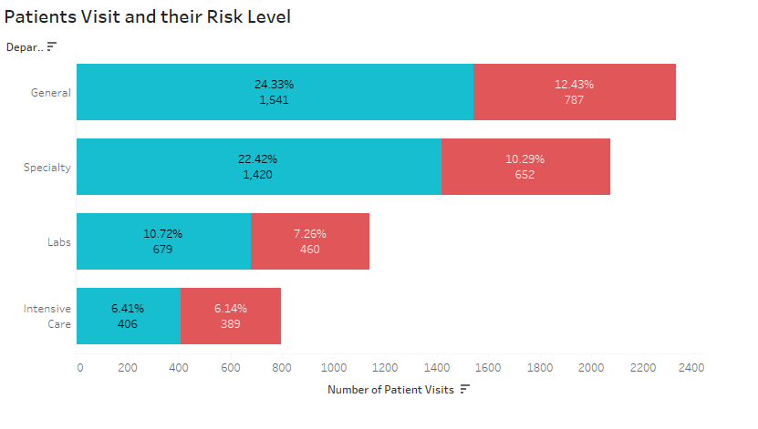

The above chart shows four categories General, Speciality, Labs, and Intensive care criteria to which the patients were admitted for diagnosis. This chart also represents the risk profile of divisions that indicates organized percentage value for profiles with high risk and low risk for the diagnosis that can help in determining the handling strategy for the corresponding category.

### Number of doctors in every department

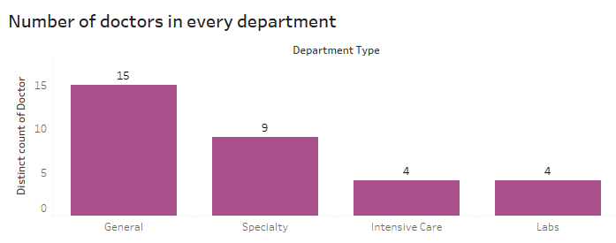

This chart helps in understanding the number of doctors allocated to each department. This analysis also helps in evaluating the time required for a patient to go through the pre-assessment tests that can reduce the risk factor by summarizing the root cause of the visit. This strategy can help in determining and admission of the patient for the service towards the consultation with the concerned doctor as per the availability.

### Number of patients in each branch

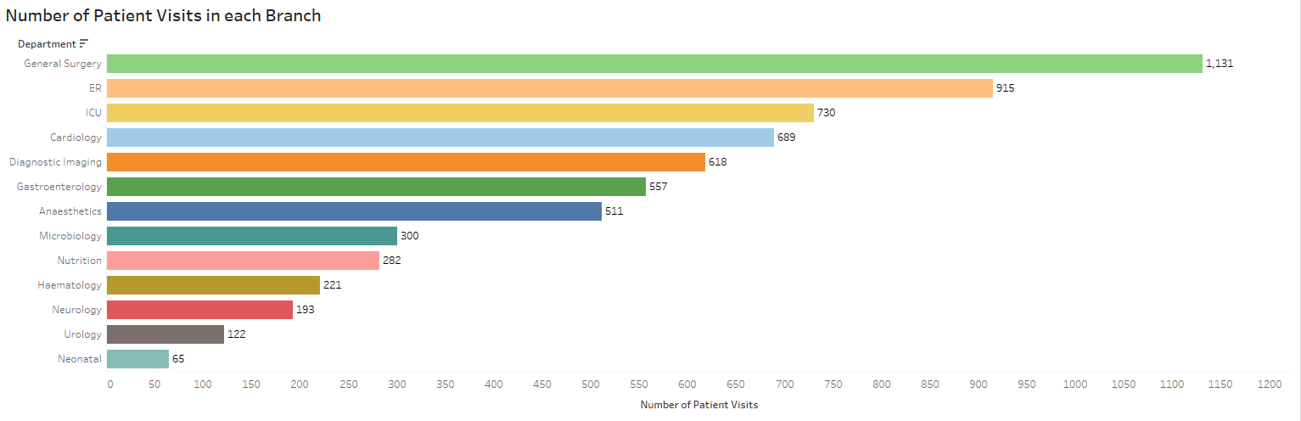

Consultation towards individual department can be visualized using this chart that summarizes the patient traffic on visitations. Understanding the stream of patients visits helps in determining the effort needed to be exhibited by the individual department to fulfill the rate of service needed in minutes to the relevant patient visit.

### Revenue Assessment on each doctor

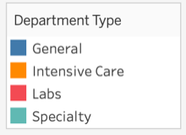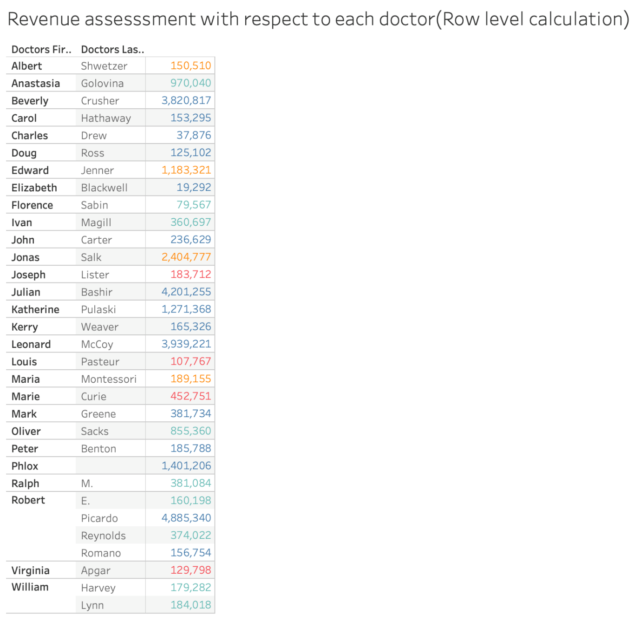

This chart represents the revenue that is generated by an individual doctor that determines the value of the resource and also can help in determining if the revenue has a chance increase by involving the specialty doctors that show more service time. This strategy can not only help with revenue but also in diagnosis time management evaluation, to cut the timing or to increase the department efforts to the individual class.

### Year over Year revenue

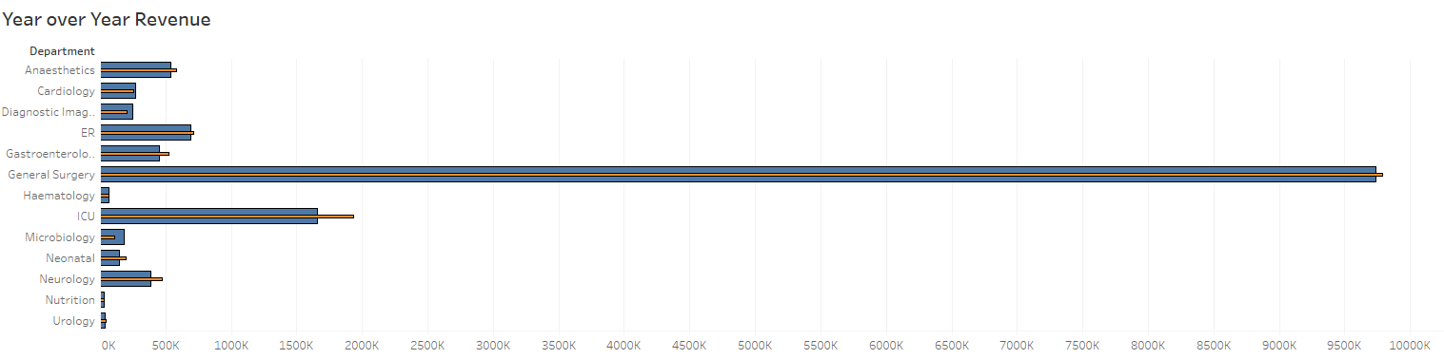

This chart helps in analyzing the revenue generated by all departments to administer the development result as increased or decreased with performance yearly. This can also help in implementing the needed capabilities to the departments that have the potential to increase the overall revenue.

### LOD Include

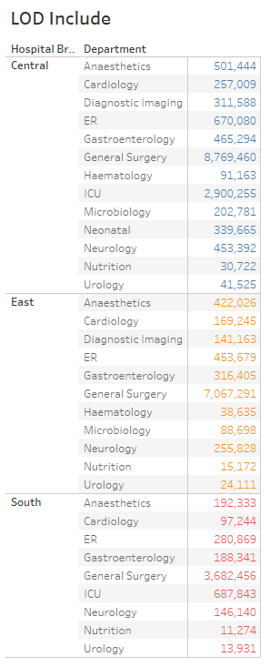

Here, we have used INCLUDE level of detail expression, in this view the tableau has added the dimension(Hospital branch) including additional dimension(Department) in the view in order to determine the values for the expression. Here, we have used INCUDE level of detail expression in order to calculate at fine level of detail in the database and then re-aggregation is done at the coarser level of detail in our view. Therefore, we can see different aggregate values for Revenue measure for each different Department for particular Hospital Branch(e.g central, east and south) in our view.

### Dashboard



Here , we have presented the insights for Hospital visits data. Here, we can view four charts Number of Patient visits with there Risk Level, Number of Patient visit in each branch, Year over year revenue for 2017 and 2018, and Level of detail with INCLUDE expression.

# **Conclusion**

After visualizing the data and building the root cause analysis on specific scenarios, we are assured to draw the sight on the conclusion. The conclusion includes the complications that the hospital may foresee with the patient traffic and risk profiles towards the doctor availability, and department availability to work with the level of attention needed to the individual risk profile. We also analyzed the insights on the revenue generation to determine the efficiency of the organization's departments that helps the administration to review the level of effort needed and assess if the individual department met the requirements. The analysis pursued by patient history and doctors who belong to the respective departments where the services are offered gives us insights to meet the targets on reducing the risk level and evaluate the effort management.

With the evaluation, we can take the number of patients, department individuals, and doctors at different zones as factors on organization global performance. This scenario helps in adjusting the workload and efforts needed by the individual department where the number of patients can be admitted into the respective risk level and consider the treatment process and adapting the necessary equipment to determine the minutes and income to the expenditure.

In a situation, when the number of doctors do not meet the traffic of patients' risk levels, the organization can appoint the out-house doctors to the availability schedule that helps in increasing the reliability of the organization for most of the cases at different risk levels. An assigned management group can administer the low-risk case and high risk profiles to the individual needs with allotting the doctors who can follow a pattern to mitigate the risk on the timeline for the available department once the treatment is defined.

With our analysis and recommendations, we strongly believe that the organization can improve with handling cases to a better level and also manage the doctors, and individuals of department to the possible extent by allotting the cases as per the risk level. This analysis also digs into the revenue details where an oversight of the yearly based growth and decline can be witnessed and measures can be taken into consideration as per the best busiess model.

# **References**

1] Joshua N. Milligan (2019). *Learning Tableau 2019 Third Edition*, Birmingham, UK: Packt Publishing Ltd.

2] Salaymeh, A. (2020, February). Using Row-Level, Aggregate,and Level of Detail Calculations. Chapter 4, Visual Analytics. Presented at 2020 Spring session, LTU, Southfield-MI, U.S.